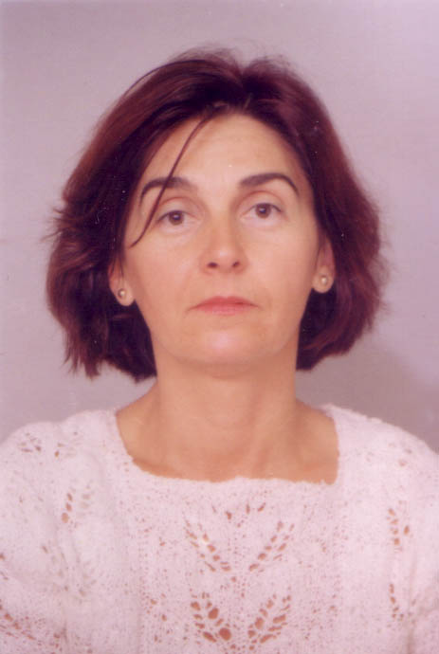

CURRICULUM VITAE

PERSONAL DETAILS:
Full name:Margarita Petrova Petrova
GSM number:0034/617199755
E-mail:m.petrova1955@abv.bg
Age:54 years old
Date of birth:24.01.1955
Place of birth:Popovo,Bulgaria
Nationality:Bulgarian
Family status:divorced

EDUCATION AND QUALIFICATIONS:
2004 - 1 year`s Spanish course in Barcelona
2004 -6 months guides` course in Bulgaria
1996 -received degree as secondary school technical teacher in the University of technics in Varna
1992 -English course for intermediate proficiency
1973-1978 -received degree as an engineer in the Higher Institute of mechanical engineering of Varna
1968-1973 -Secondary school of german and russian languages

PROFESSIONAL PROFILE:
2008 -experience as a babysitter in Vienna/Austria/
2007-2008 -experience as a baby-sitter,cleaner,kitchen worker in Palma
2005-2006 -experience in an Office materials` plant in Barcelona,as a cleaner and as a worker in agriculture
2004 -experience as a carer of an ill woman in Germany
2004 -experience as a guide in a bulgarian hotel
2001-2004 -experiance in bulgarian hotels as a chambermaid
2000 -experience in hotel Tennerhof in the austrian resort Kitzbuhel as a kitchenmaid and chambermaid
1994-2001 -experience in hotels in the bulgarian resorts Golden Sands and St. Elias as a reception clerk,kitchen clerk and potman,chambermaid
1979-1991 -experience as a mechanical engineer in the Institute of Shipbuilding of Varna,Bulgaria

LANGUAGE SKILLS
Native language: Bulgarian
Other languages:
German -excellent written and spoken
Russian -excellent written and spoken
Spanish –excellent spoken and good written
English -intermediate proficiency

Social skills and competences:
Adaptable and able to quickly establish very good rapports with collegues after my experience in the range of tourism in Bulgaria and Austria

2
Organisational skills:
Not too wide experience, but if I receive a chance for example in a foreign country hotel or other establishment I am sure I will develop my organisational skills and I will make the best of my experience and the languages I know.It is important to me being a part of a team,to work feeling an increased responsibility and personal freedom.Furthermore, I am sure,I`ll learn knew things.

