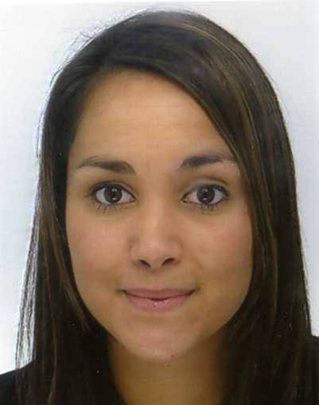
Laura GARNIER
15 chemin de la croix Beudet
72360 MAYET
06.28.73.00.85
02.43.46.44.78
laura146.garnier@laposte.net

French nationality
Born on October 10th, 1988
Driving licence
Curriculum Vitae

EDUCATION

Studies

2006-2008: BTS (HND) management assistant, High School G.Touchard,Le Mans (72) FRANCE
2005-2006: A-levels literary, High school Racan,Chateau du Loir (72) FRANCE

Languages

English: Basic level
Spanish: Basic level

Computer skills

Microsoft Office (Word,Excel,Publisher,Access,Powerpoint)

WORK EXPERIENCE

June 2009 to present: saleswoman, KIABI, Le Mans (72) FRANCE

October 2008 to December 2008: hostess and saleswoman, Museum of modern art of Saint Etienne (72) FRANCE

July 2008 to August 2008: Agent of production, ADINE (factory), Mayet (72) FRANCE

June 2008 & June 2009: Cleaning lady, ONET SERVICE, 24 Heures du Mans, Le Mans (72) FRANCE

July 2007: Organizer and presenter in the “Forum des Jeunes”, Municipal youth service, Le Mans (72) FRANCE

September 2005 to June 2007 (on Saturdays and school holidays): Cashier, INTERMARCHE, Le Lude (72) FRANCE

HOBBIES AND INTERESTS

- Tennis: 15 years

- Travelling: Morocco, Turkey

- Reading, cinema

